Lab Analysis Breakfast Wrap
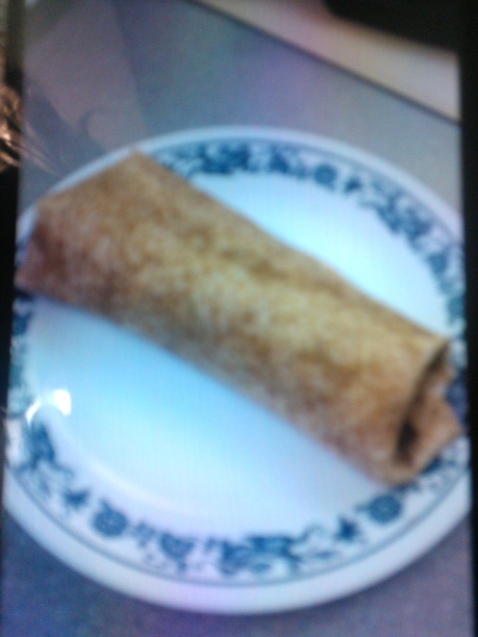
Amanda Hipkin
Cost

10 pieces of bacon $3.60
5 Eggs $1.85
½ Green pepper $ 1.40
Cheddar cheese $1.83
5 Tortillas $4.25
1/2 onion $0.23
Sour cream $2.09

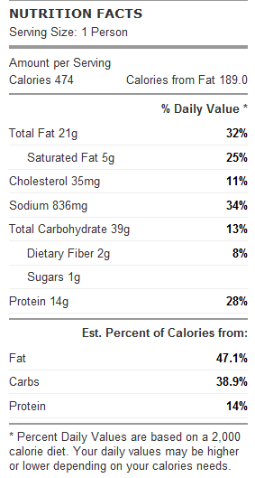
The breakfast wrap was very flavourful and tasted good. It was yummy but still mostly healthy so it is a good snack to have and be able to make. The eggs had the right amount of flavour and the bacon added a lot of flavour. The eggs didn’t look very appetizing at first but when combined with the onions, bacon and sour cream it all blended well and tasted good. When put together all the ingredients looked well together. When wrapped it had a nice appearance but I had a whole in my tortilla so it fell apart and didn’t look very good.

I haven’t bought a wrap like this at the store before but since it wasn’t store bought we knew exactly what was being put into it. The bacon wasn’t healthy but since we knew what it was and where it was from its better. We were also able to add whatever we want to it so it could be our own thing and taste the way we wanted.

Method

To make the breakfast wrap start by preheating the oven to 350 degrees and cook the bacon on a baking sheet for 20 minutes.
Wisk the eggs with the cheese and chopped green peppers then put into frying pan and scramble.
Chop the onions and sauté in a frying pan with cooking oil till golden brown and caramelized.
When everything is prepared put sour cream on the wrap and then place eggs in the middle. Add bacon and onions and top with cheese then fold.

