Chunky Apple Muffins

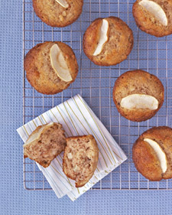
Yield Makes 6

Ingredients
  - 1 medium Granny Smith apple, peeled, cored, and quartered
  - ½ cup sugar
  - 1 cup all-purpose flour
  - 1 teaspoons baking soda
  - 1/4 teaspoon salt
  - 1/4 teaspoon ground cinnamon
  - 1 large eggs
  - ½ cup buttermilk, room temperature
  - ¼ cup vegetable oil

Directions
- Preheat oven to 400 degrees. Place muffin liners in muffin pan.
- Cut 3 apple quarters into 1/4-inch dice; cut remaining apple quarter into 6 thin slices for garnish.
- Whisk together sugar, flour, baking soda, salt, and cinnamon in a medium bowl.
- Add diced apple; toss to coat.
- In a separate bowl, whisk together eggs, buttermilk, and oil in a small bowl.
- Gently fold buttermilk mixture into flour mixture until just combined; do not overmix.
- Divide batter among muffin cups, filling each about three-quarters full.
- Top each with an apple slice.
- Bake until muffins are brown around edges and spring back when touched, 16 to 18 minutes.
- Let muffins cool slightly, about 5 minutes, before turning out of tin onto a wire rack. Serve warm or at room temperature.

